**8-BIT MULTIPLICATION**

**EXP NO: 3**

**AIM**: To write an assembly language program to implement 8-bit multiplication using 8085 processor.

**ALGORITHM:**

1. Start the program by loading the first data into the accumulator.
2. Move the data to a register.
3. Get the second data and load it into the accumulator.
4. Multiply the two register content.
5. As the multiplication of two 8bit numbers can be maximum 16bits so we need register pair to store the result.
6. Halt

**PROGRAM:**

LDA 8500

MOV B, A

LDA 8501

MOV C, A

CPI 00

JZ LOOP

XRA A

LOOP1: ADD B

DCR C

JZ LOOP

JMP LOOP1

LOOP: STA 8502

RST 1

**INPUT:**

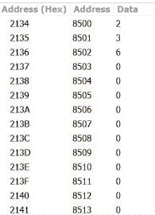

**OUTPUT:**

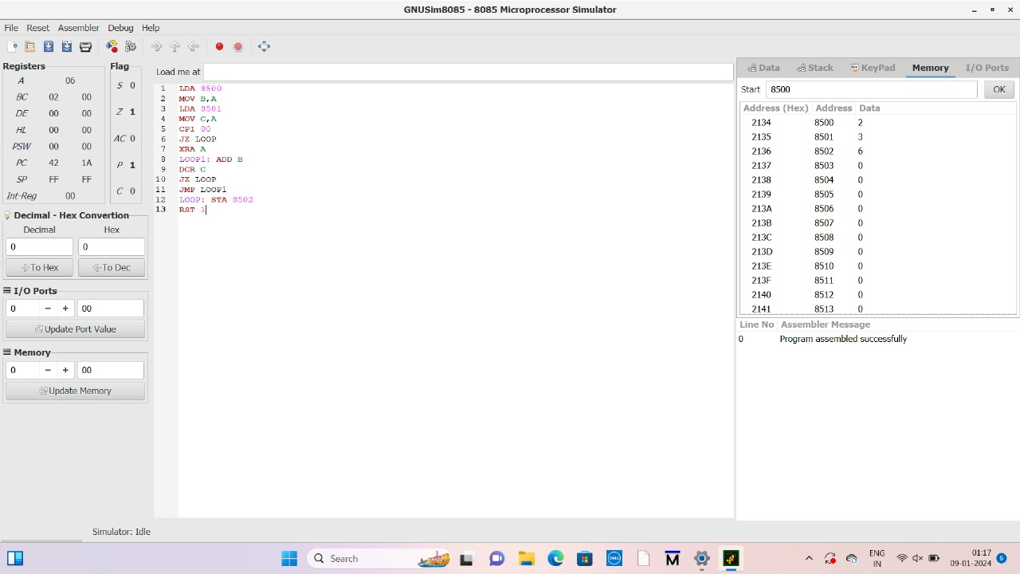

**RESULT:** Thus the program was executed successfully using 8085 processor simulator.